Professor:

* Jason Bond

Unit Overview

* Experiential Learning
* Co-ops must be at least 30% of the time spent in academic study for programs longer than 2 years, and 25% for programs less than 2 years
* Apply for anything that interests you

Work Integrated Learning Definition

* Partnership between an academic institution, host organization, and a student

Co-operative Education as an Experiential

* Use reflection as a learning tool
  + Rienforcing, learning academic theories, further developing skills, facilitating life-long learning
  + A hands on experience

7 co-op activities

* Job search strategy
* Cover letter, resume, interview support
* Competency assessments
* Work term placement (activities on the job)
* Site visit
* Work term report, submission
* Post-term debrief of presentation

Reflective Learning

* Passive learning
  + Read the textbooks, follow the teacher, write exams, forget everything
* Active learning
  + Engage in conversations
  + Be part of a community
  + Ask questions, figure out answers
  + Contribute to learning and teach each other
  + Engage with ourselves
  + Reflect back on what has been taught
* Reflection-in-action
  + At any moment, you can “think on your feet” to resolve the issue
* Reflection-on-action
  + Trying to make sense of the experience after it has occurred
    - You must do both!
* What is the difference between an active and a passive learner?
  + Active learning means engaging with the ideas and concepts, reflecting on the deeper meaning, and asking and answering questions about the subject.
* What does Schon mean by reflective learning in-action, on-action, and for-action?
  + I don’t know, but essentially you need to reflect back on an experience that has occurred and try to make sense of it for you to “really learn it”
  + Reflection In-Action
    - Reflecting while participating
  + Reflection On-Action
    - Reflecting after the experience has taken place
  + Reflection For-Action
    - Reflecting on how the experience may apply moving forward
* What strategies do you already engage with that help you to remember what you learn?
  + At the end of each class / note taking session, I’ll ask myself what the core concepts were of what I learned today
* Are there any active learning strategies that you are willing to try to enhance your learning?
  + At the end of each class, take 10 minutes to reflect on the ideas of what I learned and go to every office hours to discuss the topics with the professors

Useful Resources

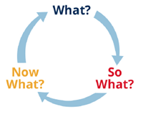

* Ask these three questions in every office hours, and ask yourself these questions!!:
* What?
  + Prompts you to reflect on what you did
  + **“Summarized, what did we learn today?”**
* So what?
  + Gets you to think about what you learned
  + **“Why is it important, and what is it used for?”**
* Now what?
  + What to do next
  + **“What else is this implying, and what subject is coming next?”**
* Gibb’s Reflective Cycle
  + 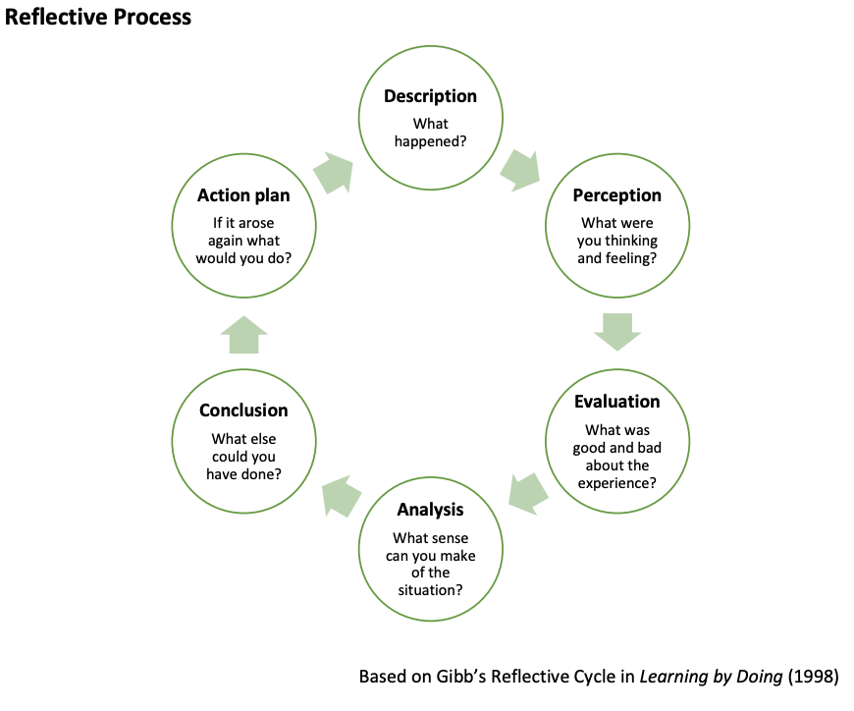
  + Reflective writing
    - Not a diary of what has happened
    - Not a collection of facts
    - Not a summary of notes from class
    - A way to put into context your learning
    - A way to step back and look at the BIG picture
    - A way to get clarity outside of the moment
    - A chance to **develop new ideas**

REFLECTION

* To really learn something, you need to reflect back on what you have just experienced and develop new ideas about it.
* This can apply to all my courses
  + And other areas of my life. I’ll start a “reflection log” instead of a journal

In Class

* Jason Bon
  + HINF 130 and HINF 110
  + Undergrad and masters in HINF
* Katie Rowe
  + Co-op assistant

Next week is a zoom link interviewing students who’ve already gone through co-op

Read

* You can use Jason as a reference if you need
* Get set up on Digital Health Canada
  + Become a member
  + There’s a free membership available through your faculty
* Next week, just show up and hear from students who have finished their co-ops

Esquimalt Chamber Of Commerce

* Treasurer ED - Bruno